**A REPORT ON MHEP PROJECT TEAM MEETING THAT WAS HELD ON 16TH FEBRUARY 2021 AT 5 PM IN THE E 11 LABORATORIES, FACULTY OF ENGINEERING AND TECHNOLOGY, EGERTON UNIVERSITY, NJORO.**

PREAMBLE

The MHEP project is a plan which involves multidisciplinary efforts to design, fabricate, test and commission a mini hydroelectric power station along river Ndarugu in Njoro subcounty, Nakuru County, Kenya. The power generated is to be supplied to street lights and other selected loads within Egerton University then later on to the neighboring community. The project is to be automated and interfaced with a wireless control for remote management and teaching purposes. This project shall be implemented with support from KENGEN, GDC, SCODE and Maastricht school of management’s personnel and funds.

OBJECTIVES

1. To design, fabricate, test and commission a power plant in a cheap, reliable and affordable way to Egerton University first, then its neighbors.
2. To train and learn emerging skills; GIS, Internet of Things, Artificial Intelligence, Cloud computing and automation.
3. To promote multidisciplinary cohesion by creating opportunities for students and collaborators.

SCOPE

This report gives an insight of the experience, concerns and emphasis that were expressed during the meeting. Below is are the minutes of the meeting.

BODY

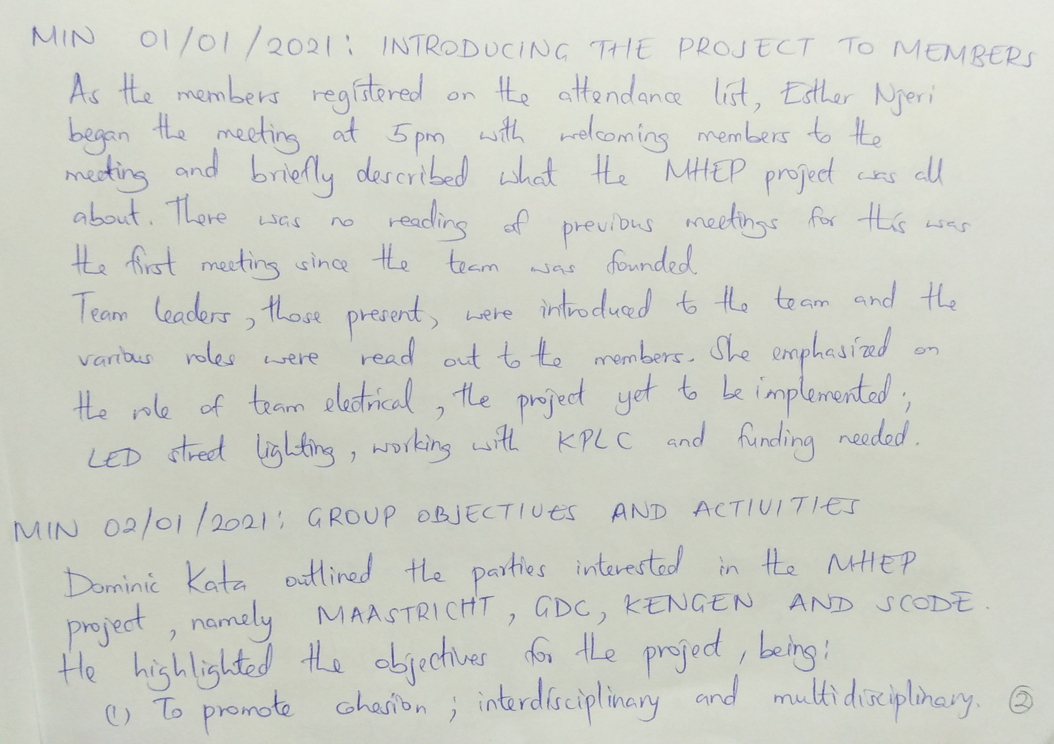

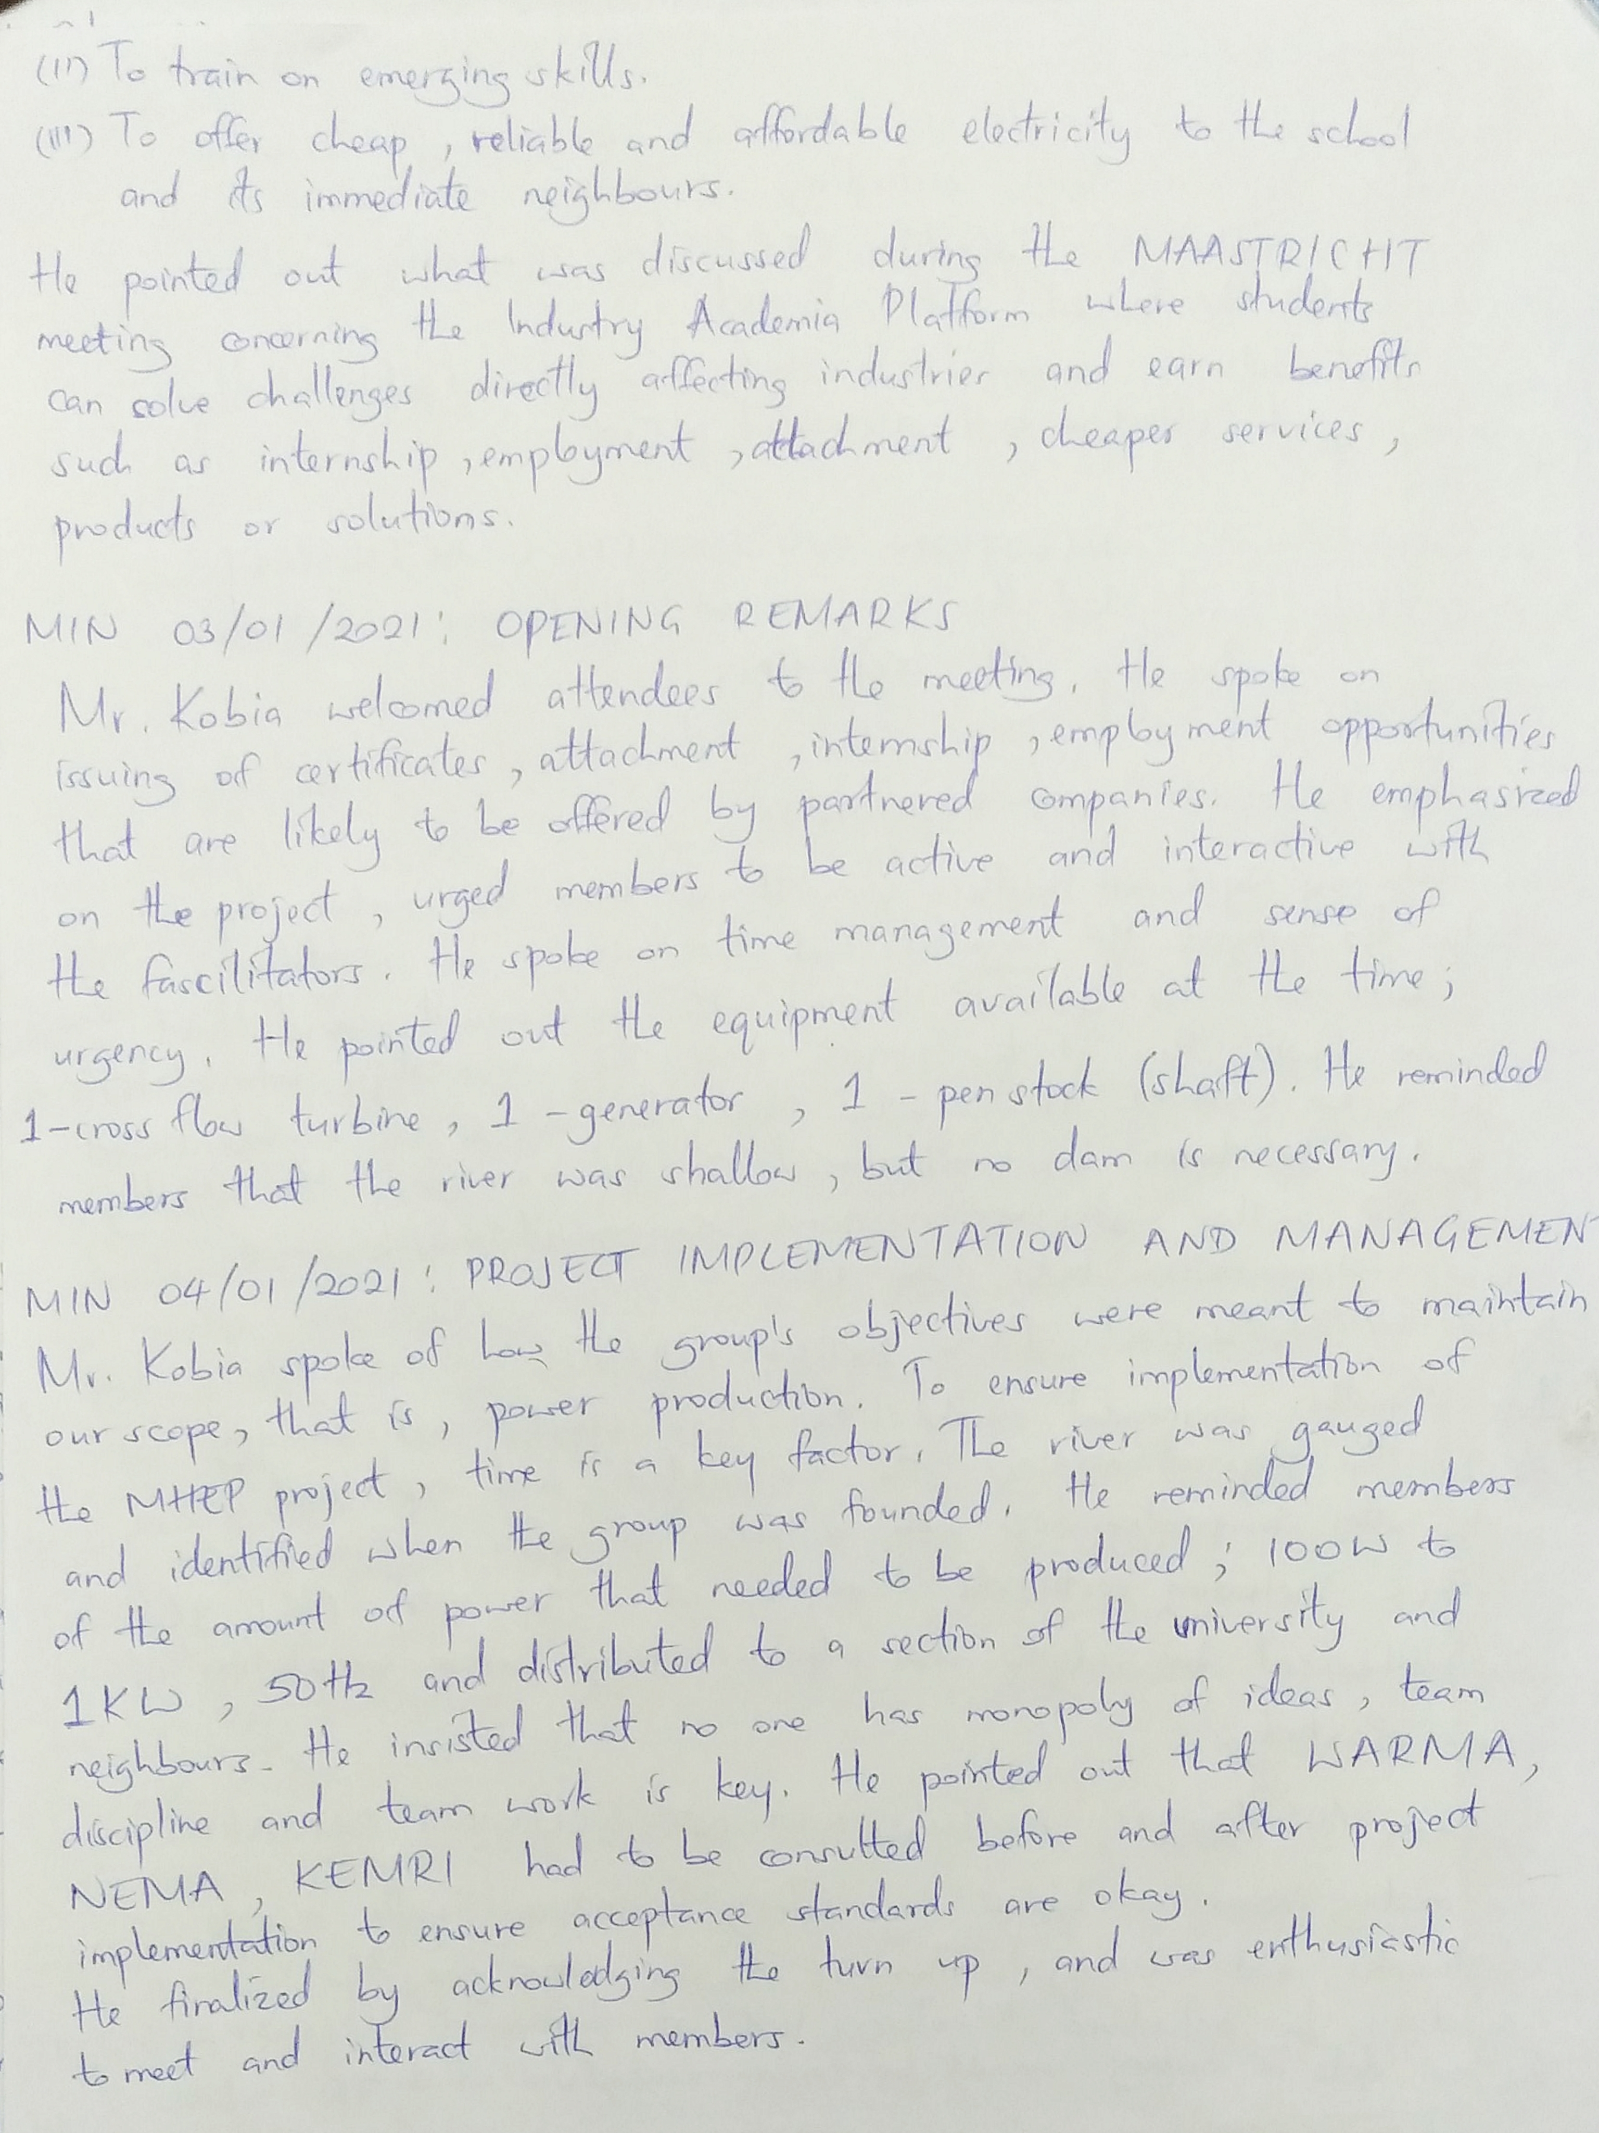

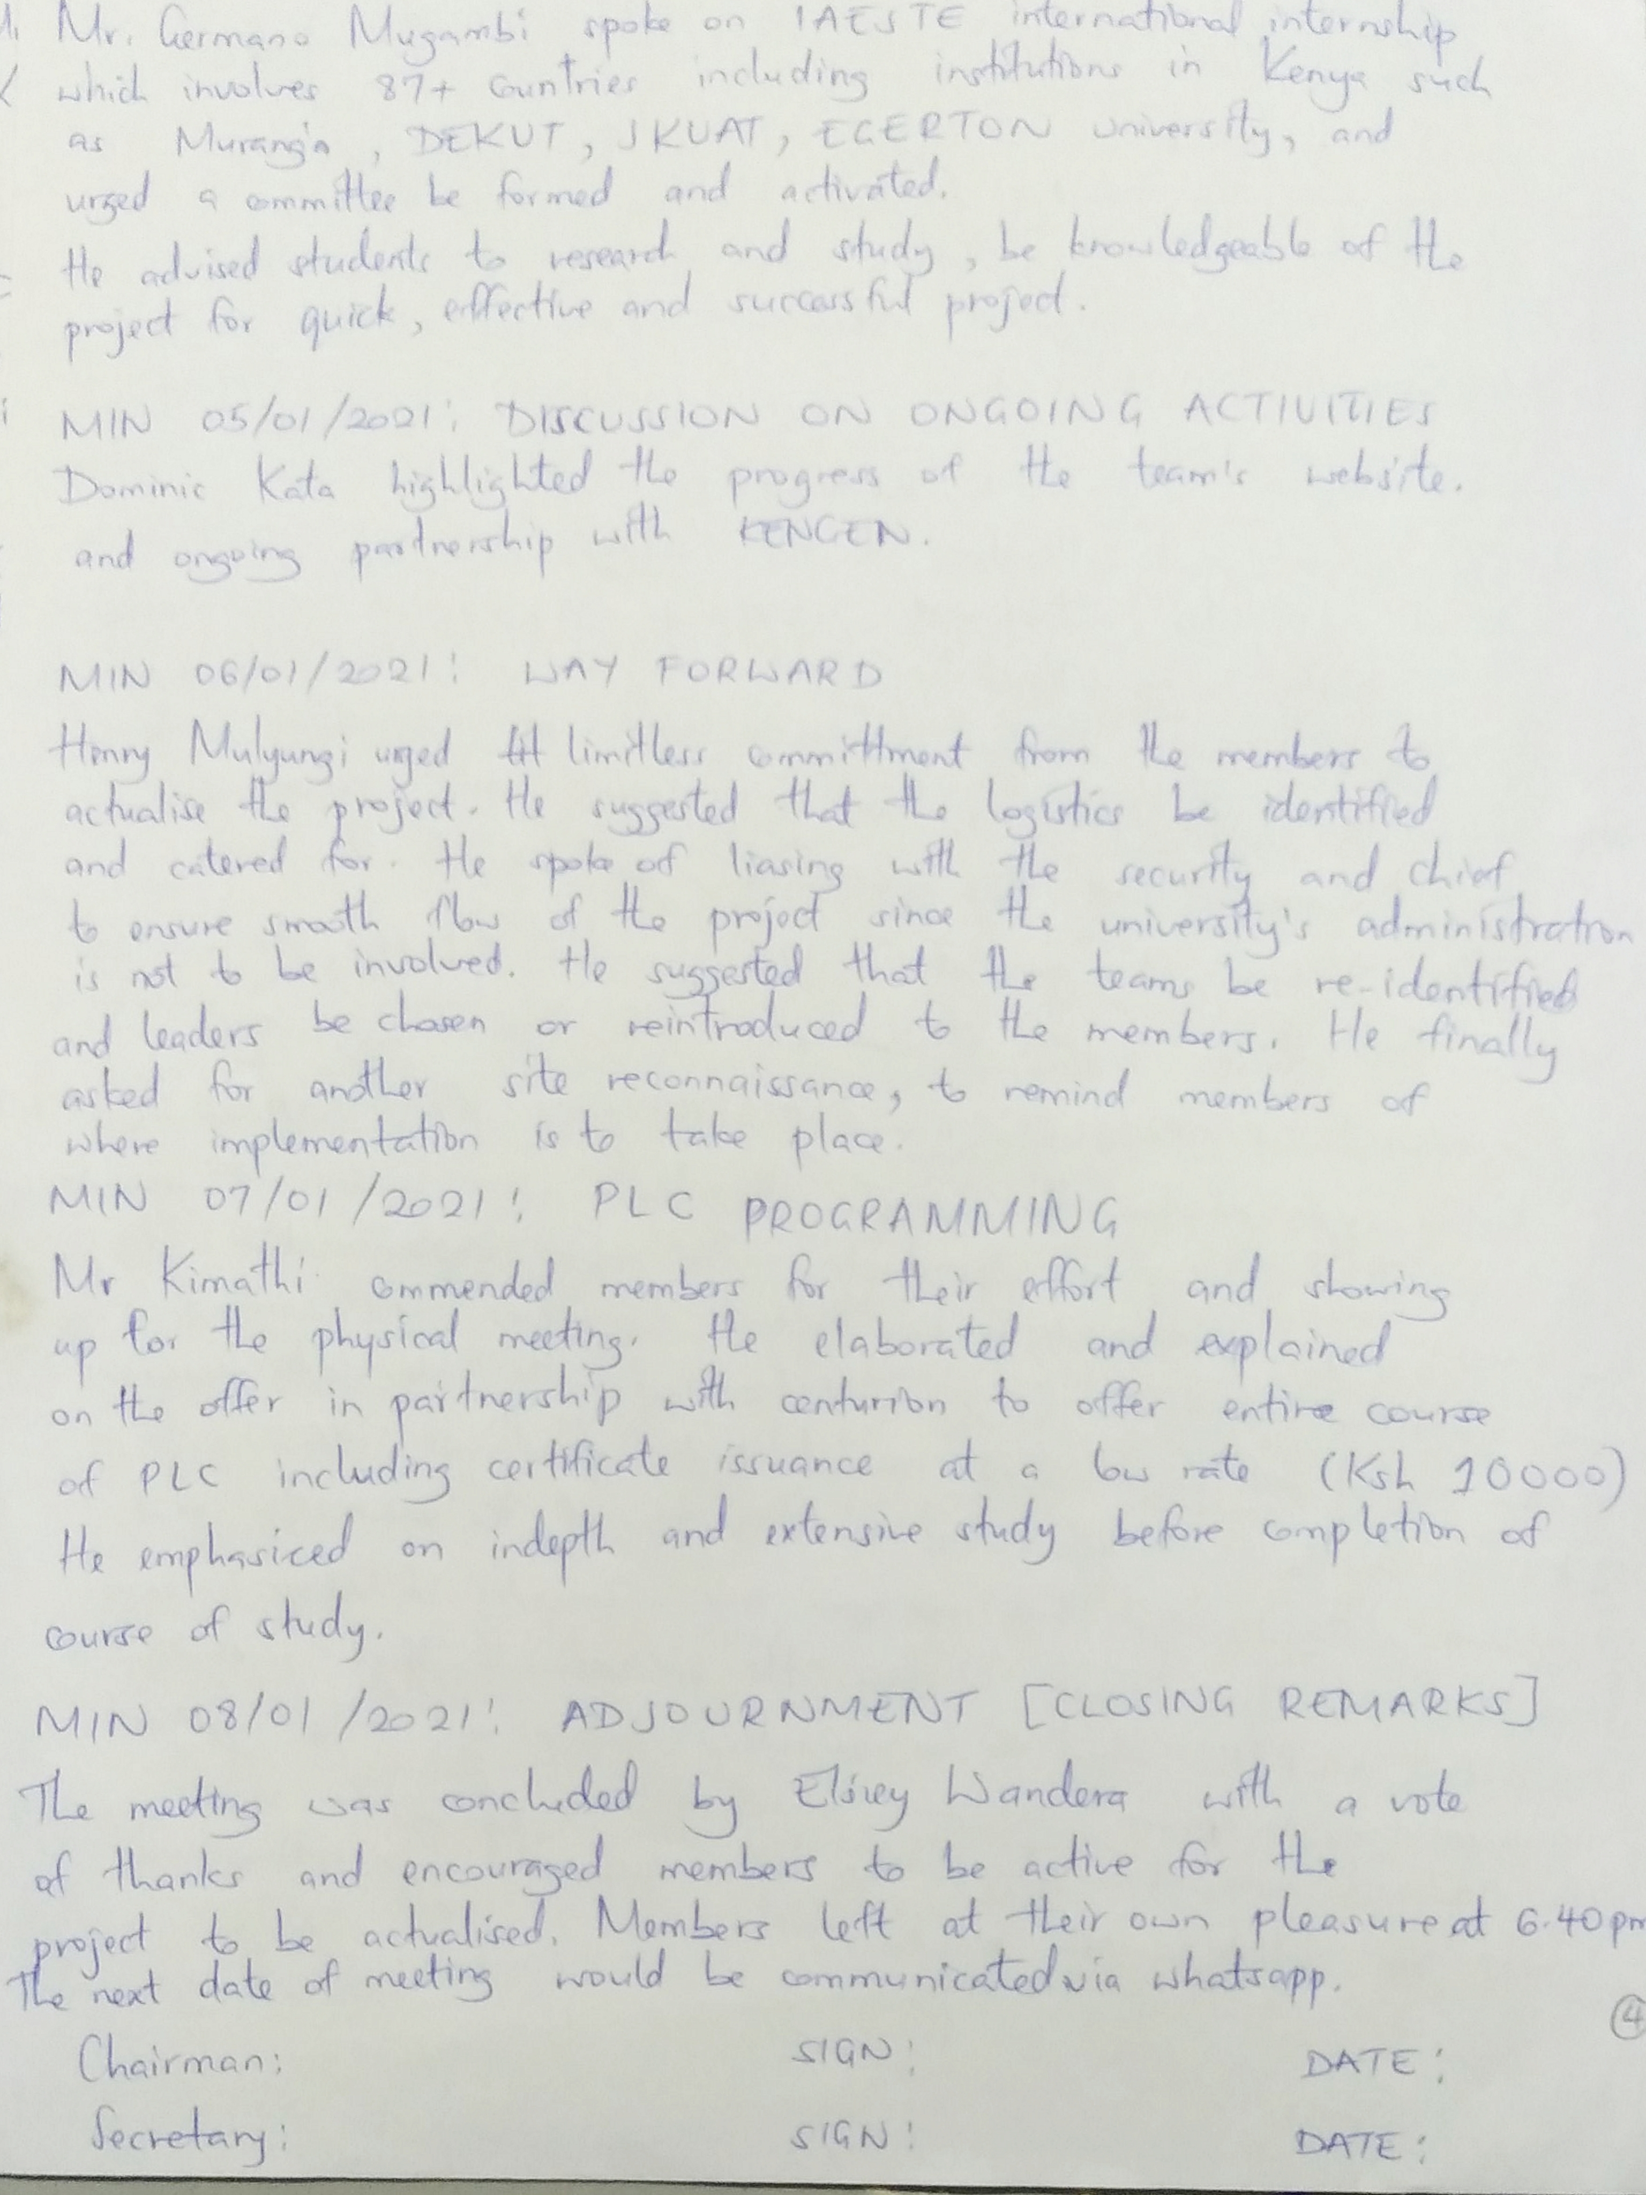

EXECUTIVE SUMMARY

The main agendas to be met were; members registration, introducing the project, group objectives and activities, opening remarks, project implementation and management, discussion on ongoing activities, way forward, PLC programming and closing remarks.

ACKNOWLEDGEMENT

The team members would like to thank the facilitators Mr. Kobia Mucheke, Mr. Germano Mugambi and Mr. Patrick Kimathi for availing themselves to share their knowledge and wisdom. The team appreciates and holds them in high esteem.

The team would like to acknowledge and thank the partners in absentia; Maastricht, SCODE, GDC and KENGEN. We hope to meet and work with you very soon.

The team leaders would also like to thank the /16s and former UASU leaders represented by Henry Mulyungi for showing interest in this project.

I would like to thank the team leaders who spoke on the agendas of the meeting; Dominic Kata and Esther Njeri Wang’ondu. Thank you to the members who showed up for the meeting. The turn up was overwhelmingly encouraging and hopefully together we fulfil our designated duties and implement the objectives of the MHEP project.